**IOT LAB**

**Program No - 07**

**Program Title – Fire Detection**

**Aim – To turn on the LED and Buzzer upon detecting a fire.**

**Hardware Required**

* Arduino Board
* Buzzer
* LED
* Temperature Sensor
* 2x240 Ohm Resistor

**Circuit Diagram-**

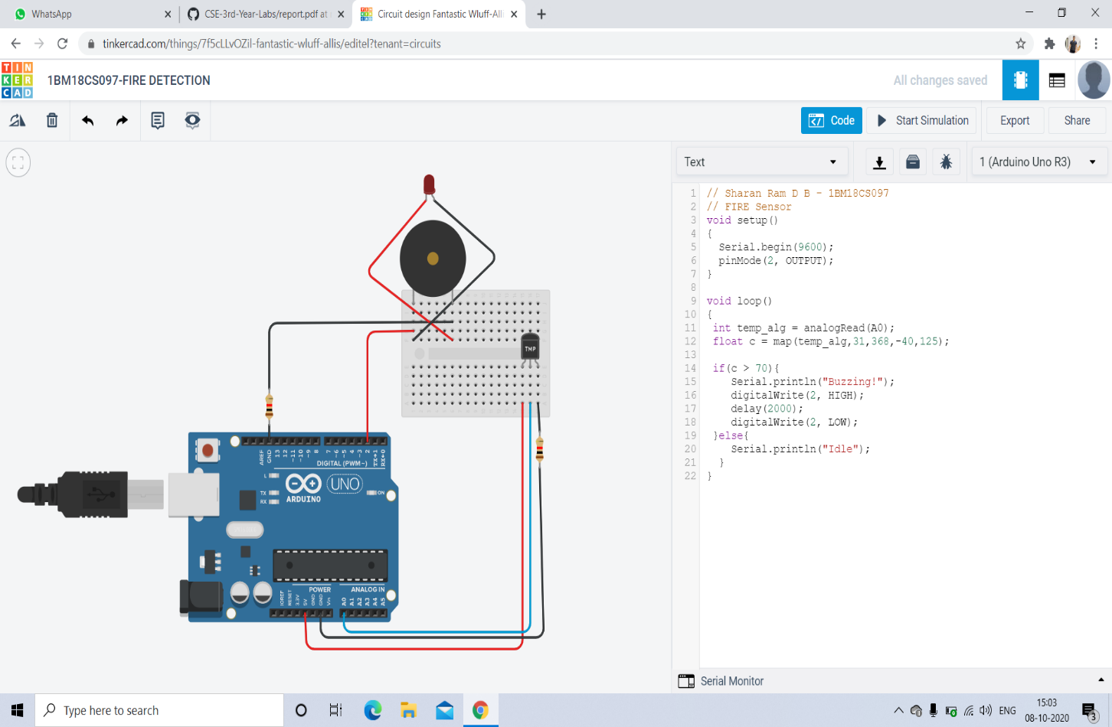

Code-

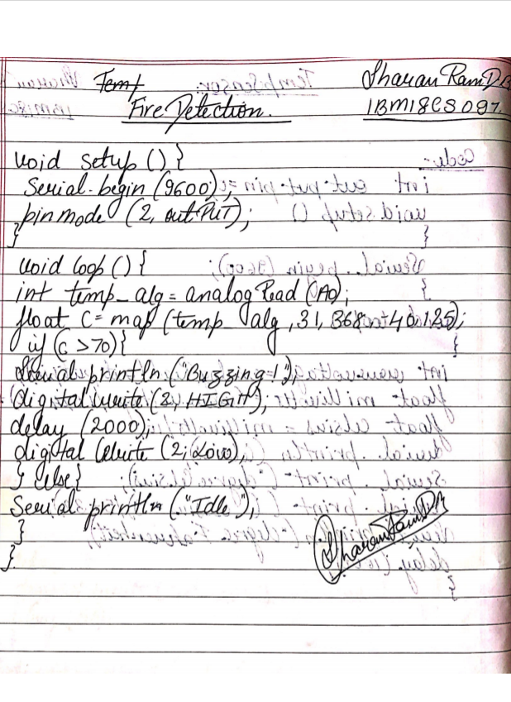

**Observation /Output-**

**LED and the buzzer is turned on when the fire is detected.**